**ANTI SLEEP ALARM FOR STUDENTS**

This circuit saves both time and electricity for students. It helps to prevent them from dozing off while studying, by sounding a beep at a fixed time interval, say, 30 minutes. If the student is awake during the beep, he can reset the circuit to beep in the next 30 minutes. If the timer is not reset during this time, it means the student is in deep sleep or not in the room, and the circuit switches off the light and fan in the room, thus preventing the wastage of electricity.

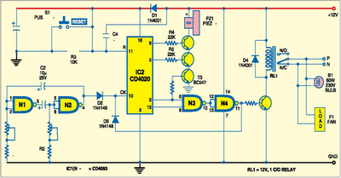

The circuit is built around Schmitttrigger NAND gate IC CD4093 (IC1),timer IC CD4020 (IC2), transistors BC547, relay RL1 and buzzer.The Schmitt-trigger NAND gate (IC1) is configured as an astable multivibrator to generate clock for the timer (IC2). The time period can be calculated as T=1.38×R×C. If R=R1+VR1=15 kilo-ohms and C=C2=10 μF, you’ll get ‘T’ as 0.21 second. Timer IC CD4020 (IC2) is a 14-stage ripple counter. Around half an hour after the reset of IC1, transistors T1, T2 and T3 drive the buzzer to sound an intermediatebeep. If IC2 is not reset through S1 at that time, around one minute later the output of gate N4 goes high and transistor T4 conducts. As the outputof gate N4 is connected to the clock input (pin 10) of IC2 through diode D3, further counting stops and relay RL1 energises to deactivate all the appliances.

This state changes only when IC1 is reset by pressing switch S1. Assemble the circuit on a generalpurpose PCB and enclose it in a suitablecabinet. Mount switch S1 and the buzzer on the front panel and the relay at the back side of the box. Place the 12V battery in the cabinet for powering the circuit. In place of the battery, youcan also use a 12V DC adaptor.